Course: INFO-6103 – Enterprise Application Modelling
Assignment: Assignment #3 – Web Services Application
Title: Google Maps, News, Weather & Currency Dashboard with Customer Name Storage
Group Members:
- Modha, Namrata Sharad – 1214320
- Quimod, Brian – 1181301
- Salama-Eid, Cristine Grace – 1200707
- Brito, Jay-R – 1165408
- Philip Ukodei - 1179910
- Ardayfio, Harold Nii Oblie – 1204963
Submitted to: Prof. Christina Lederman
Date: April 8, 2025

Project Overview
This Assignment 3 into a single Flask-based web application that includes:
- Google Maps integration with live marker interaction
- Real-time weather data
- Currency exchange functionality
- Live news headlines via RSS
- Full customer database form with CRUD functionality
All features are consolidated on a single web page using home.html.

Technologies Used
- Flask (Python Web Framework)
- HTML5 + CSS3
- JavaScript (Google Maps API)
- SQLite (Database)
- OpenWeatherMap API
- OpenExchangeRates API
- Google Maps JavaScript API + Geocoding
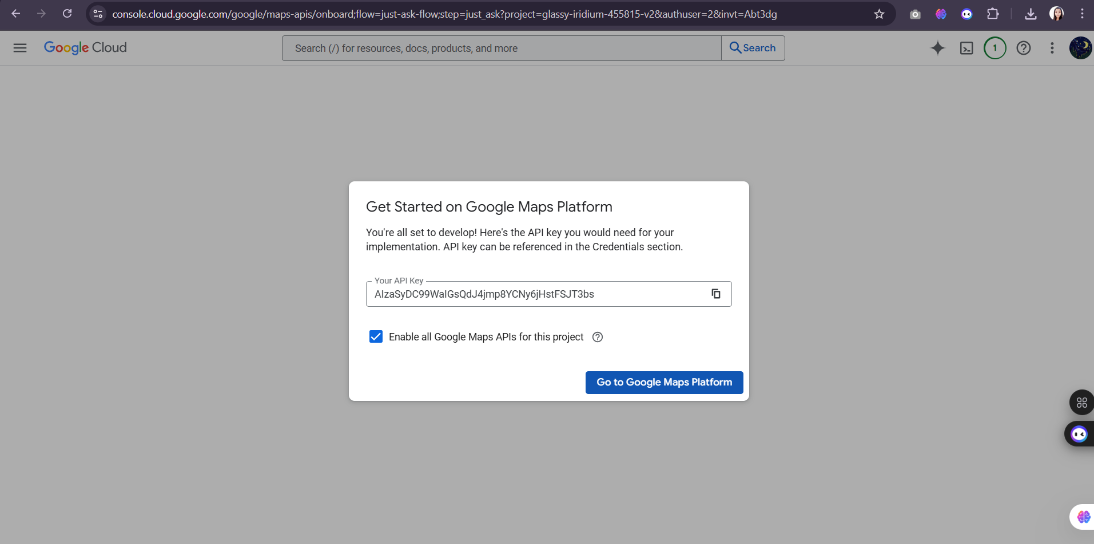

Backend Logic (app.py)
Handles both GET and POST requests at the '/' route.
Includes:
- Weather from OpenWeatherMap
- Currency exchange via OpenExchangeRates
- RSS headlines via Feedparser
- Customer CRUD via dbhelper.py

Database Logic (dbhelper.py)
Functions:
- insert_customer()
- find_customer()
- update_customer()
- delete_customer()
- get_all_customers()
Database Schema:
CREATE TABLE customers (
id INTEGER PRIMARY KEY AUTOINCREMENT,
name TEXT,
address TEXT,
latitude REAL,
longitude REAL
);

Database Configuration (dbconfig.py)
# dbconfig.py
DATABASE_PATH = 'customer_data.db'
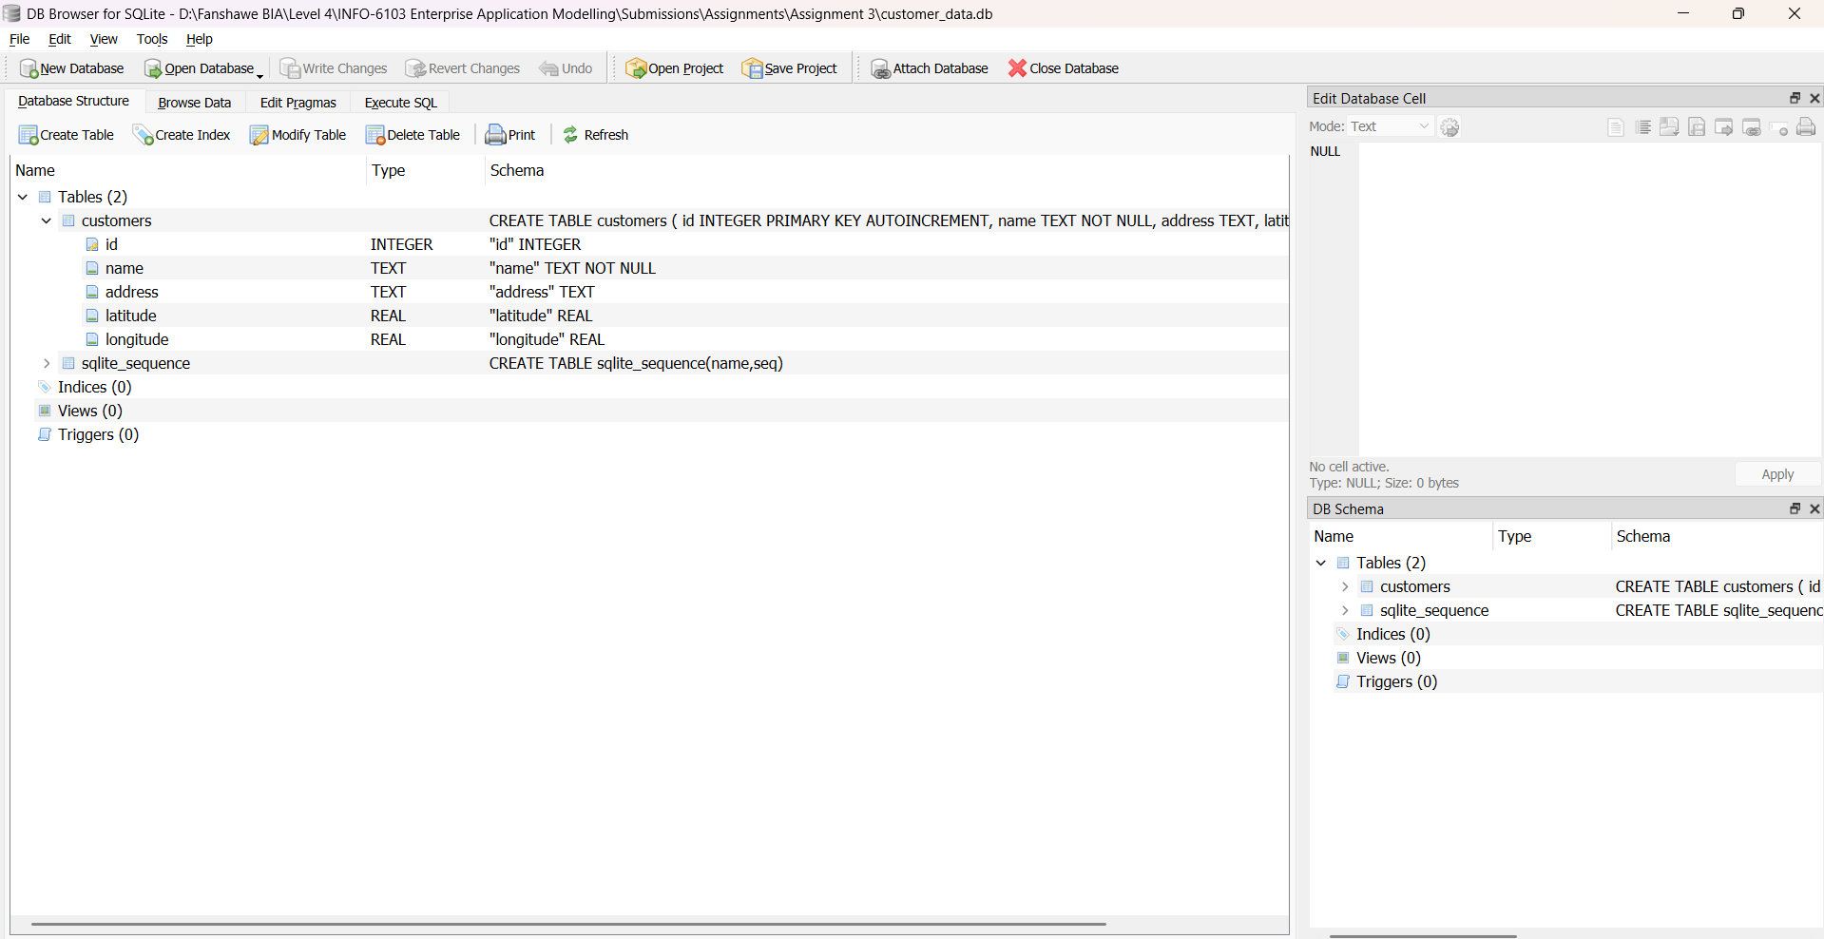

Frontend Logic (home.html)
The HTML template renders:
- Google Map with draggable marker
- Search Address button to geocode and center map
- Customer form with Add, Update, Find, Delete
- Weather, currency, and RSS feed forms
- Customer list with name and address displayed

Google Maps Integration
- Map loads with marker at default or saved location
- Marker updates lat/lng fields on drag
- Search Address button geocodes and centers map
- Zoom level set to 16 for clarity

Features Completed
- [x] Weather via OpenWeatherMap
- [x] Currency exchange with amount using OpenExchangeRates
- [x] RSS feed news headlines
- [x] SQLite database with full CRUD operations
- [x] Address-based geolocation with Google Maps
- [x] Marker updates via drag or address search
- [x] Combined all features in home.html page

Project Output
- Adding a customer
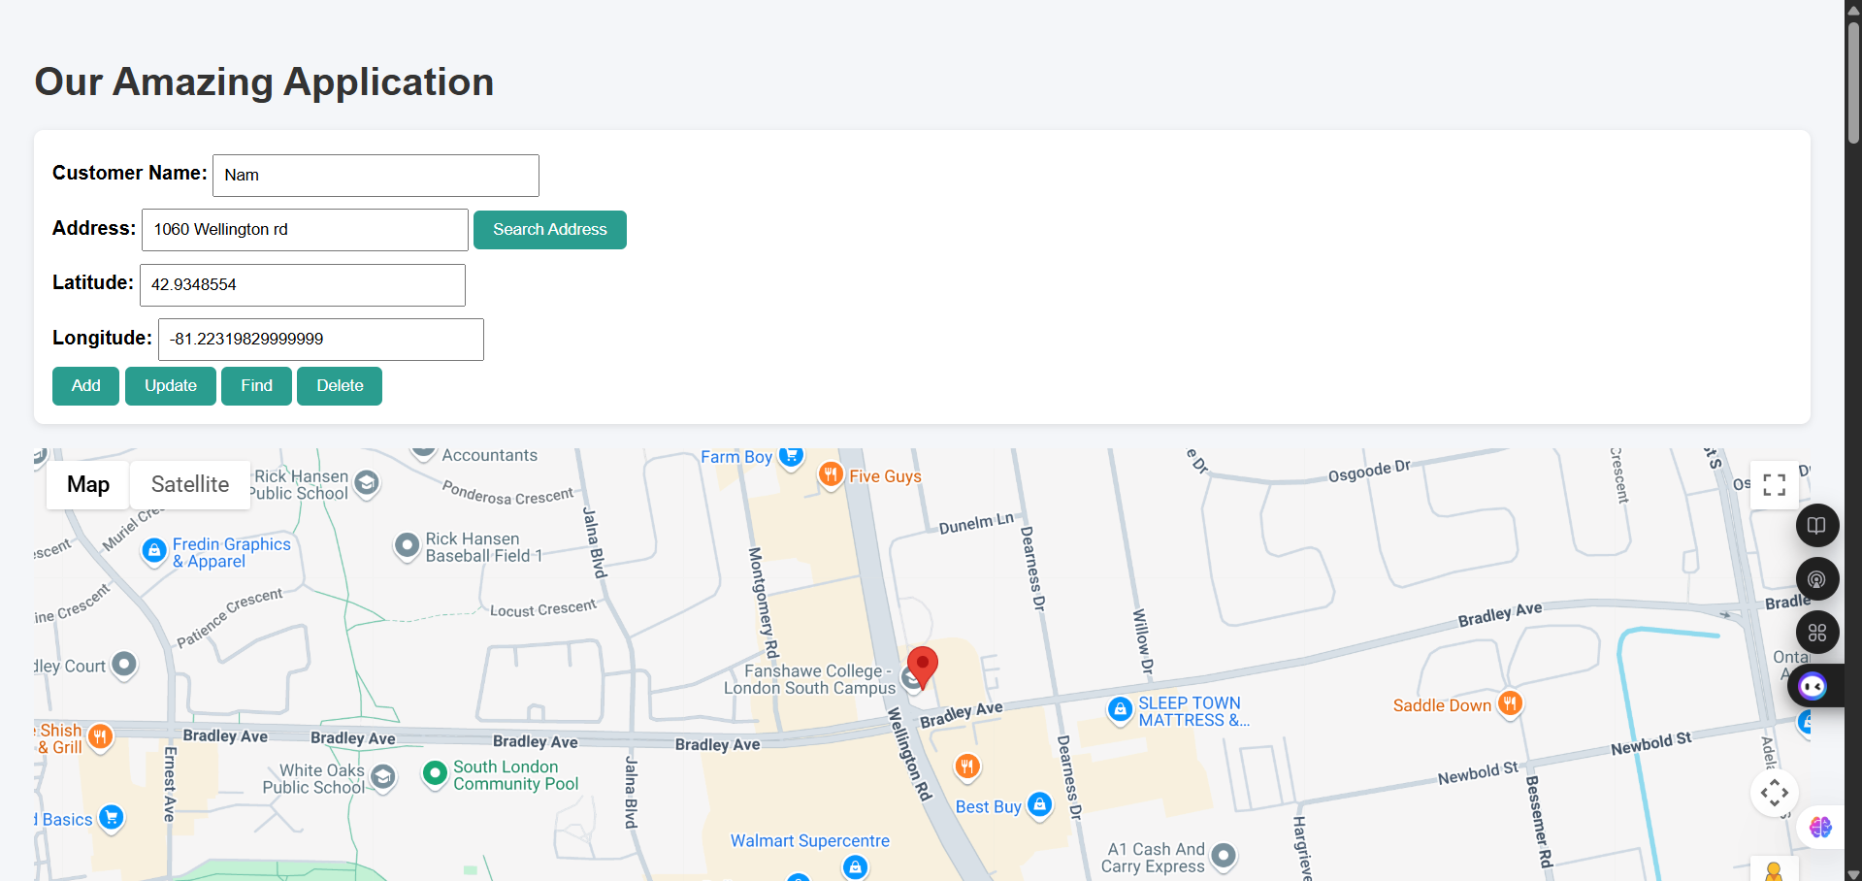

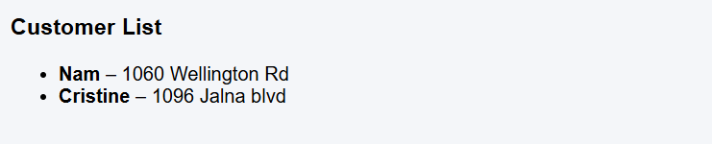
- Enter Customer Name
- Enter Address and click on search
- Click Add
- Searching address (marker updates)
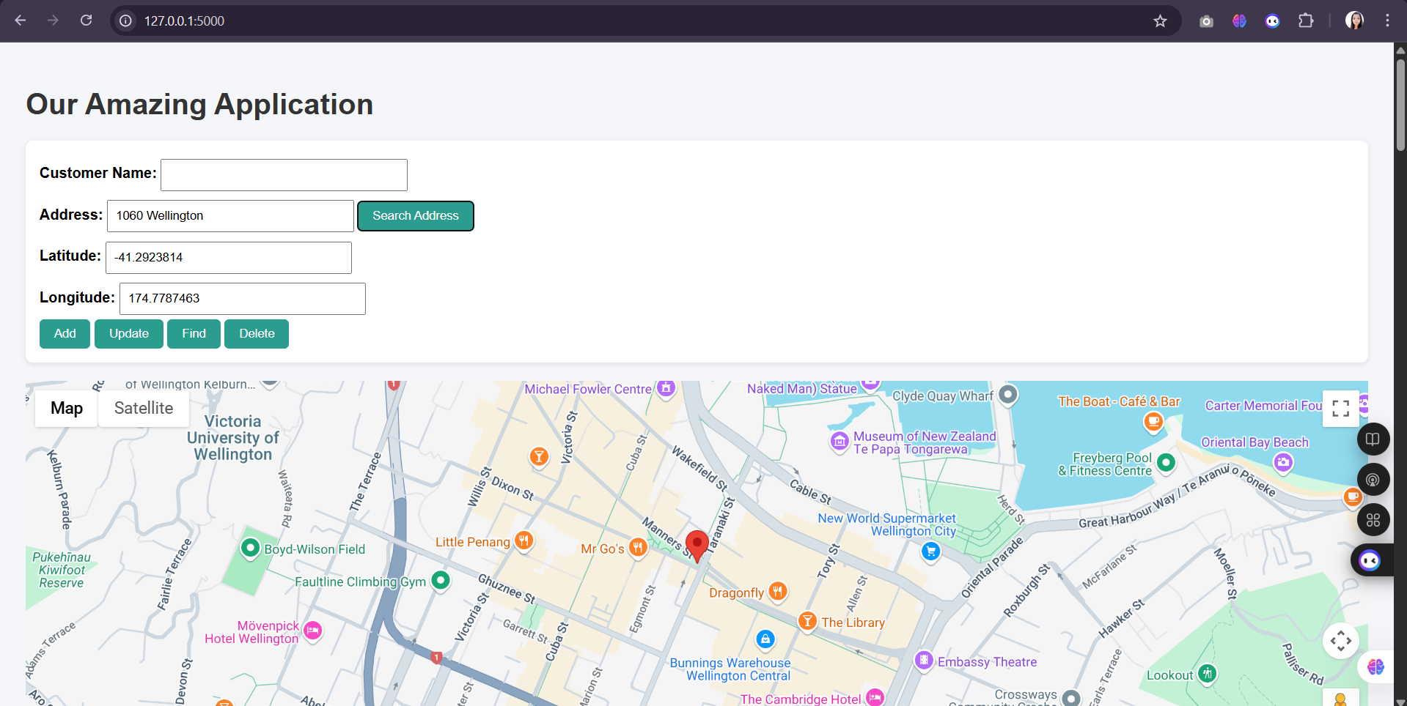
- Enter address and click “Search Address”

- Updating customer location
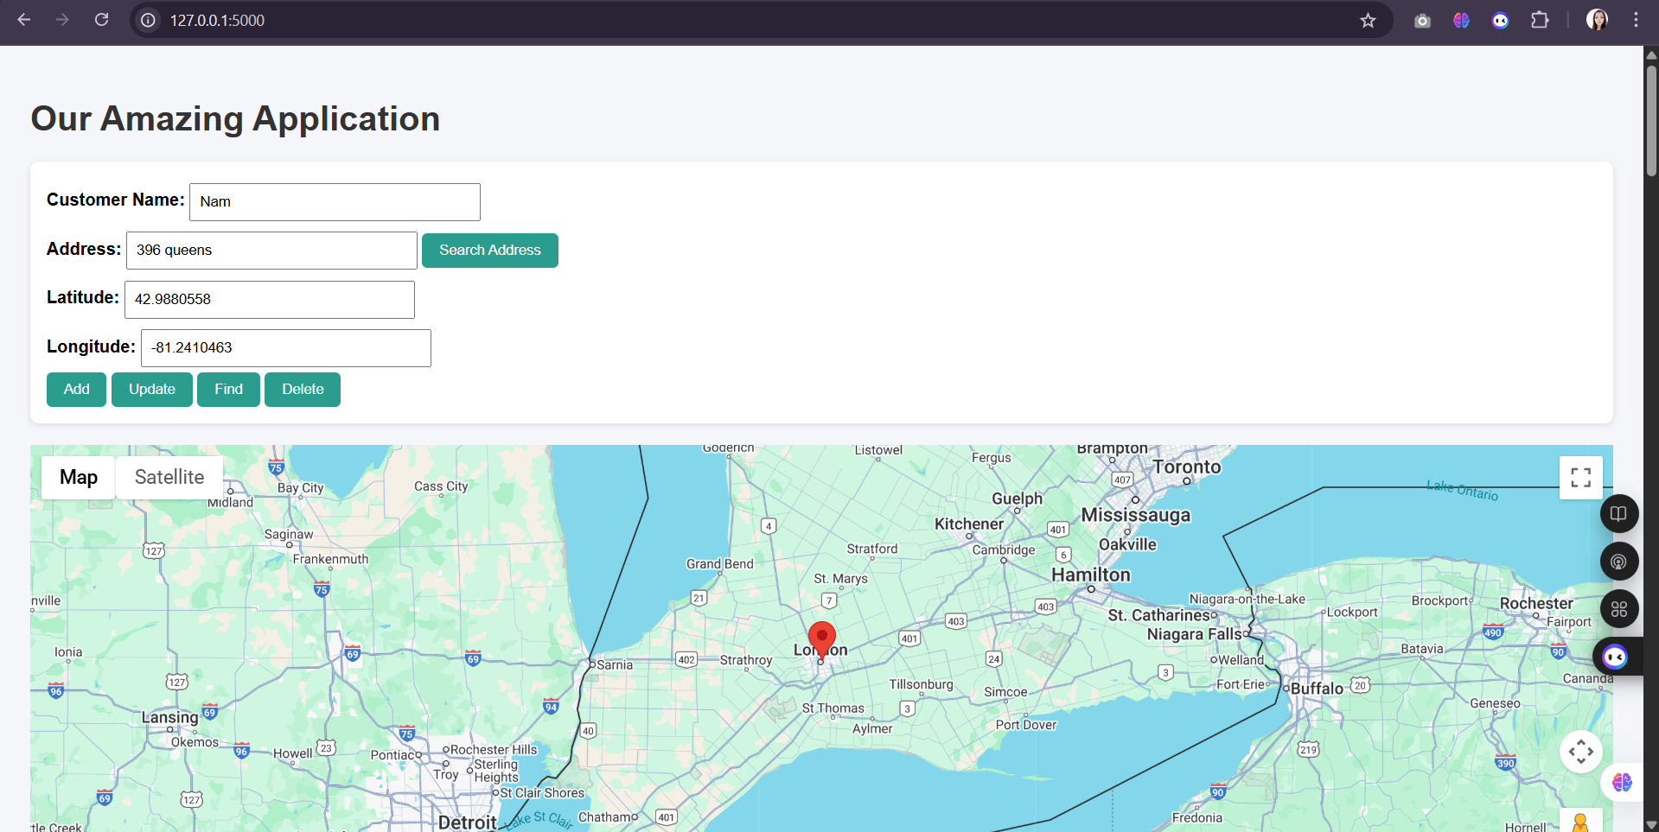

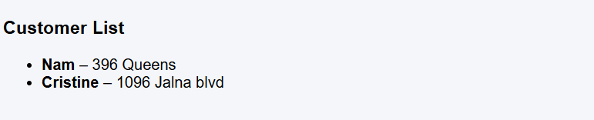
- Enter Customer Name
- Click Find
- Enter New Address and click “Search Address”
- Click “Update”

- Weather for a searched city
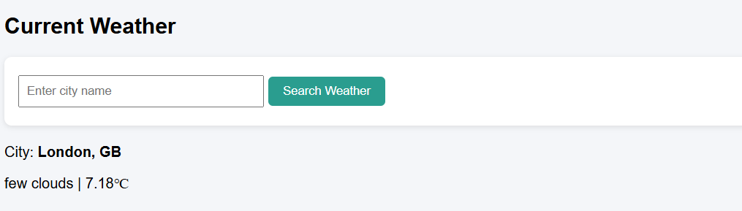
- Currency conversion (CAD to USD)
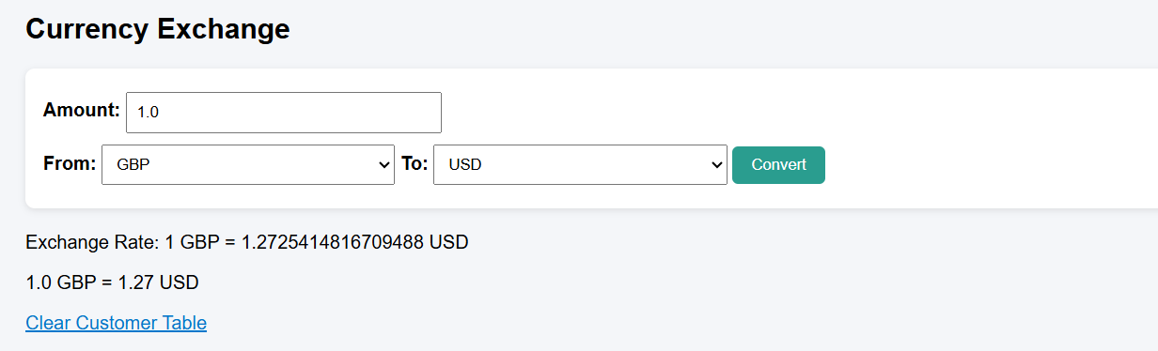
- News headlines
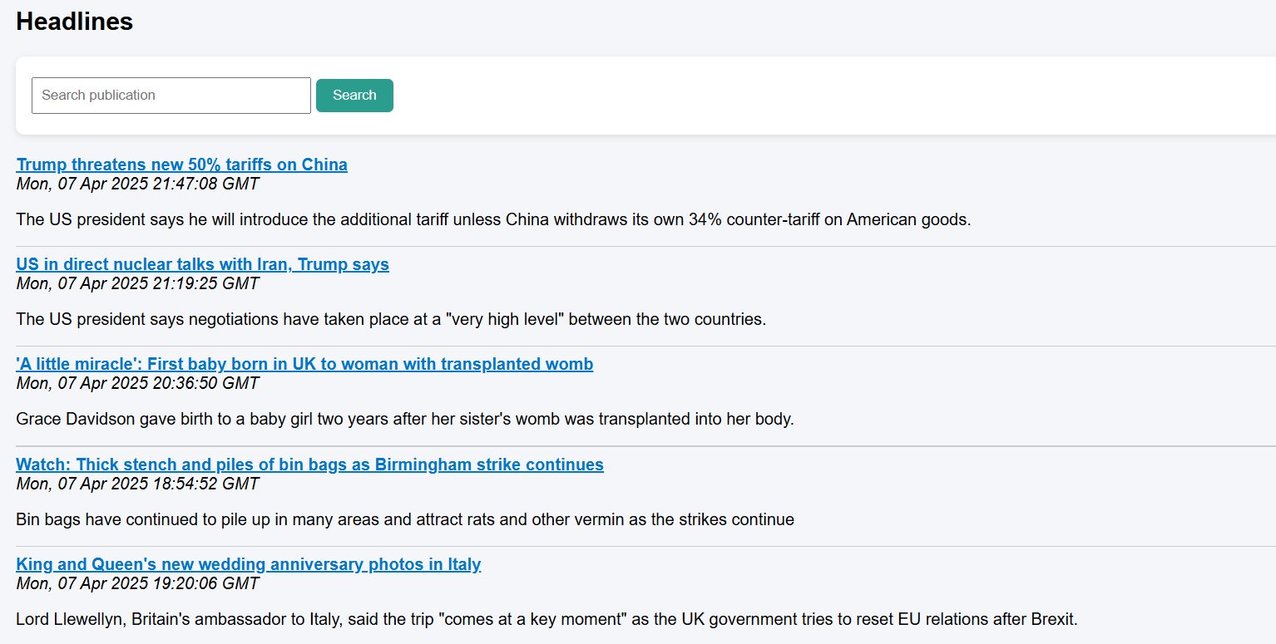
- Customer list at bottom


